HW4 – Trades
Java Programming I – Jamie Gashler
- The data structures I used were primitive types, arraylists and arraylists of arraylists. I used these because they were effective at storing the information that I needed to hold. I used arraylists to store the list of companies/stock names that the user input, while I used arraylists of arraylists to store the user input information of the stock prices and quantities. I used primitive types to store temporary/ final variables that were used throughout the code.
- The benefits of using arraylists are that it’s easily resizable, so it’s often very simple to find items in a particular position or location. For this assignment we had to find the first-most instance of the user purchasing one type of stock and sell that one before moving onto different stocks with the same name. This was very simple with arraylists. However, some drawbacks are that arraylists are often difficult to read, and sometimes I would confuse my variable names with the arrays, the syntax is very specific, and they only hold object types, so if you want to use a primitive type in an arraylist, you have to put them inside an object or use immutable classes.
- I believe I chose correctly for myself. I understand arraylists better than some other things in Java, but I feel that some of my code was redundant/repetitive. I probably could have simplified my code and made it more readable if I had used maps or other types of lists.

Result: buy something
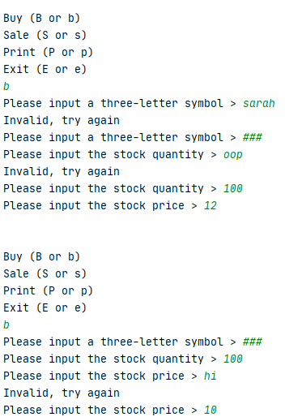
Result: print something
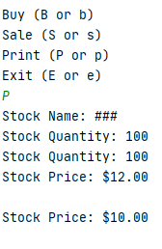
Result: sell something
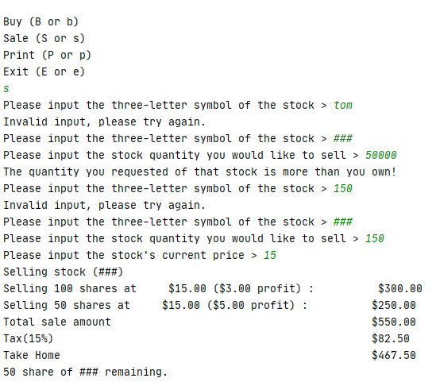

Result: Exit
